1. Set up the environment.

**You work on the project inside the VM. Download and install VirtualBox on your own machine.**

**Get the VM (Virtual Machine) image file: Compilers.vbox. It’s a pre-configured Linux system with all the needed tools installed.**

1. **Read the instruction on the course website “Getting Started with the VM”**

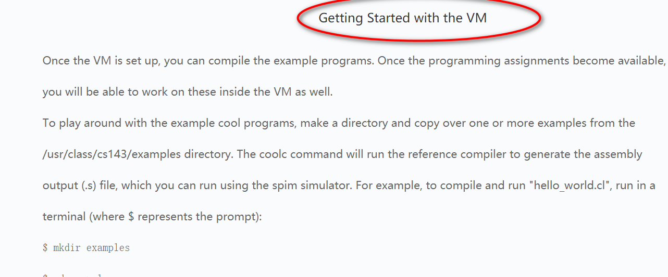

1. **Using the VM**

* The provided account is "compilers" and the password is "cool".
* We have installed what you need to do the assignments, plus a few other programs, such as vim and emacs.
* To get a terminal, click on the terminal icon at the bottom of the screen. This should get you to the point where you can start the assignments.

1. **Compile “Hello World” Programs**

Step1: create your project directory, for example named “myCoolc”, using command “mkdir myCoolc”.

Step2: create subdirectory “examples” using “mkdir examples” and copy the file “hello_world.cl” from “cool/examples” to your examples directory, using command “cp ~/cool/examples/ hello_world.cl .”

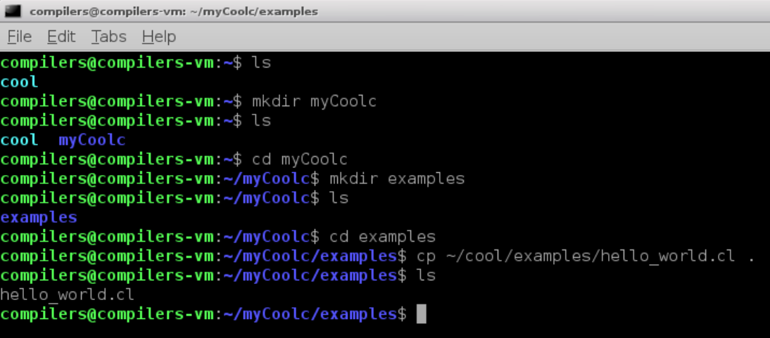

You can use command “cat hello_world.cl” to read the source file hello_world.cl

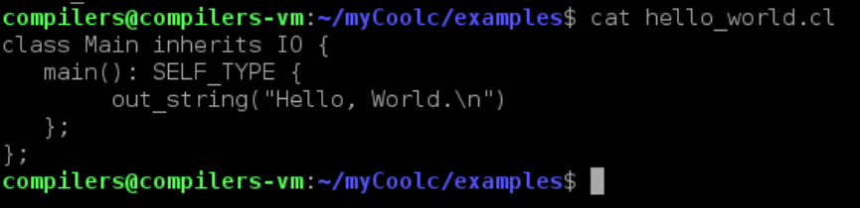

Step3: compile file “hello_world.cl”

The “coolc” command will translate .cl file to MIPS assembly code (.s file)

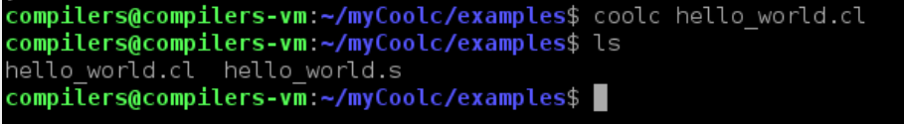

Step4: Run file “hello_world.s”

Using the spim simulator to run .s file. The command is “spim”

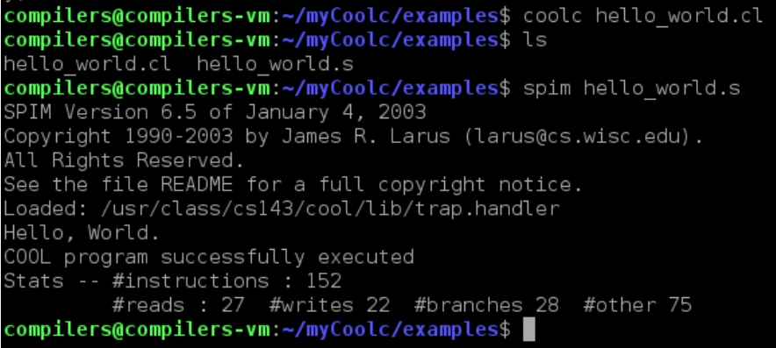

Try the other examples in the directory “cool/examples”. Through the examples you will get a better understanding of COOL.

1. **Read the file “The Cool Reference Manual” to know about Cool.**

Or watch the video lecture “02-01 Cool Overview.mp4”, “02-02 Cool Example II.mp4”, and “02-03 Cool Example III.mp4”

“The Cool Reference Manual” can be download from the course website.

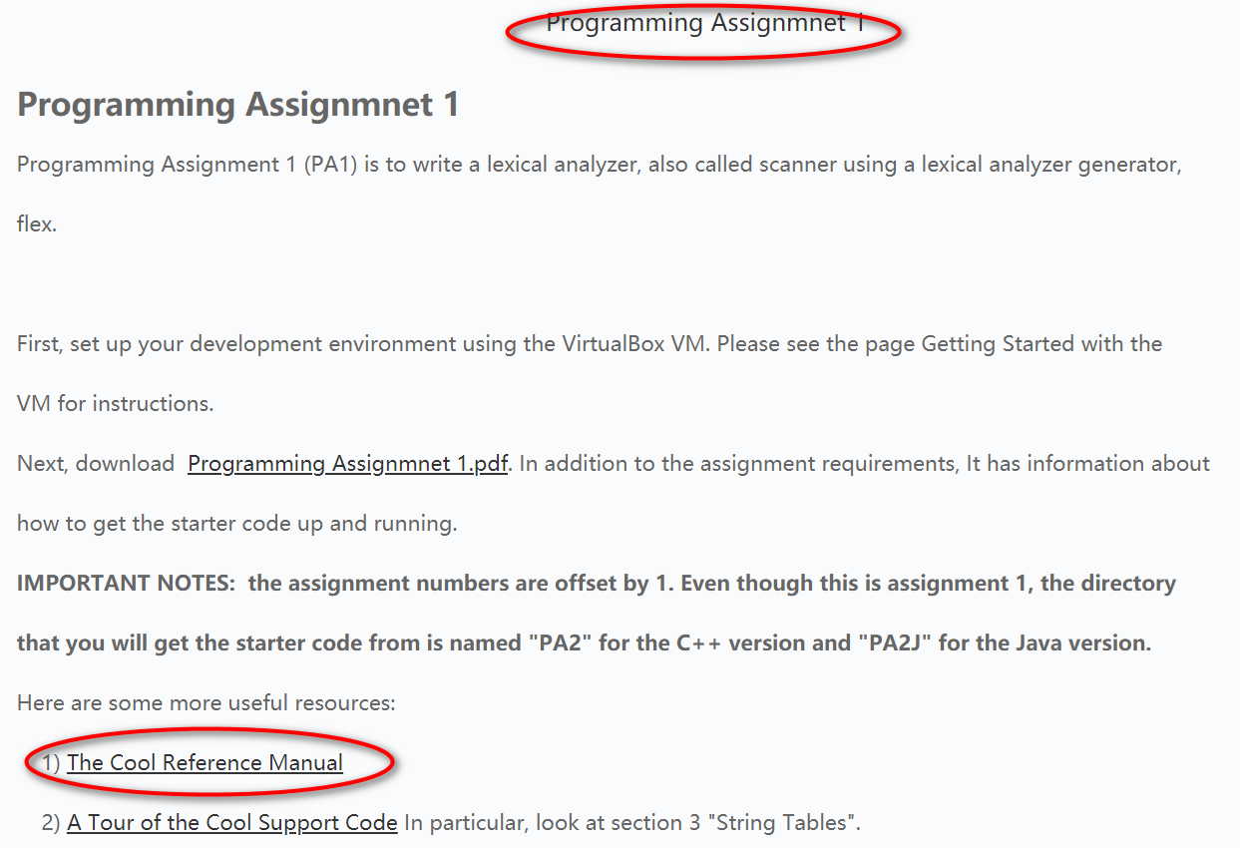

Since we do only Assignment 1: lexical analysis of Cool and Assignment 2: Parsing of Cool, you don’t have to read the whole manual.

By now, please read session 1 to session 9. These are the informal introduction to Cool.

When you begin to do assignment 1, please read session 10.

When you begin to do assignment 2, please read session 11.

You only need to read session 12 and session 13 if you are interested in. In our lab, we won’t cover these two sessions.